**Practical-17**

**AIM:** Create an XML file and XML Schema to store student information like Enrolment Number, Name , Mobile Number and Email Id.

**Code:**

<?xml version ="1.0"?>

<xsl:stylesheet version = "1.0"

xmlns:xsl="http://www.w3.org/1999/XSL/Transform"

xmlns="http://www.w3.org/TR/xhtml1/strict">

<xsl:template match = "/">

<h2><font aling="center" size=20px face=cooper> Student

Information </font></h2>

<xsl:for-each select="students/student">

<br/>

<span style="font-weight:bold;color:black;font-family:cooper">

Name: </span>

<xsl:value-ofselect="name" /><br/><br/>

<span style="font-weight:bold;color:black;font-family:cooper">

Enrollment no: </span>

<xsl:value-ofselect="enrollment number" /> <br/><br/>

<span style="font-weight:bold;color:black;font-family:cooper">

Mobile no: </span>

<xsl:value-ofselect="mobile number" /> <br/><br/>

<span style="font-weight:bold;color:black;font-family:cooper">

Email Id: </span>

<xsl:value-ofselect="email id" /> <br/><br/>

</xsl:for-each>

</xsl:template>

</xsl:stylesheet>

**Output:**

## Student Information

**Name:**

**Enrollment no:**

**Mobile no:**

**Email Id:**

**Practical-18**

**AIM:** Create Document Type Definition (DTD) for above XML File.

**Code:**

<?xml version = "1.0"?>

<?xml-stylesheettype="text/css" href= "16.html"?>

<students>

<student>

<name><font face=cooper> KRISH PATEL

</font></name><br><br>

<enroll><font face=cooper> 22BECE54007 </font></enroll><br><br>

<phone><font face=cooper> 7698

72****</font></phone><br><br>

<email><font face=cooper> krish4546@gmail.com

</font></email><br><br>

</student>

</students>

**Output:**

**JANKI PATEL**

**22BECSE54004**

**96649 7\*\*\*\***

**Jankipatel1525@gmail.com**

**Practical-19**

**AIM:** Write a php program to check if number is prime or not.

**Code:**

<?php

function check_prime($num)

{ if ($num == 1) return 0;

for ($i = 2; $i <= $num/2; $i++)

{ if ($num % $i == 0) return 0;

}

return 1;

}

$num = 263;

$flag_val = check_prime($num); if ($flag_val == 1)

echo "It is a prime number"; else

echo "It is a non-prime number"

?>

**Output:**

It is a prime number

**Practical-20**

**AIM:** Write a php script to read data from txt file and display it in html table (the file contains info in format Name: Password: Email ).

**Code:**

**data.txt:**

abc:123:abc@gmail.com

def:456:def@gmail.com

xyz:789:[xyz@gmail.com](mailto:xyz@gmail.com)

**prac_20.php:**

<table>

<tr>

<td>Name</td>

<td>Password</td>

<td>Email</td>

</tr>

<?php

$file_handkler = fopen("data.txt","rb");

while(!feof($file))

{

$line_oftext=fgets($file);

$parts=explode(':',$line_of_text);

echo"<tr><td>$parts[0]</td>

<td>$parts[1]</td>

<td>$parts[2]</td></tr>"

}

fclose($file);

?>

</table>

**Output:**

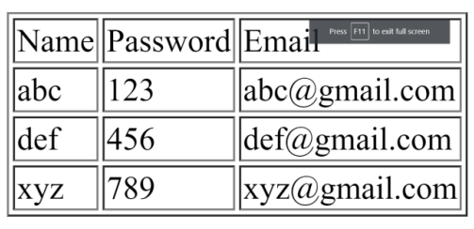

**Practical-21**

**AIM:** Write a PHP Script for login authentication. Design an html form which takes username and password from user and validate against stored username and password in file.

**Code:**

<html>

<head>

<title>PHP login system</title>

<link rel = "stylesheet" type = "text/css" href = "style.css">

</head>

<body>

<div id = "frm">

<h1>Login</h1>

<form name="f1" action = "authentication.php" onsubmit = "return validation()" method = "POST">

<p>

<label> UserName: </label>

<input type = "text" id ="user" name = "user" />

</p>

<p>

<label> Password: </label>

<input type = "password" id ="pass" name = "pass" />

</p>

<p>

<input type = "submit" id = "btn" value = "Login" />

</p>

</form>

</div>

<script>

function validation()

{

var id=document.f1.user.value;

var ps=document.f1.pass.value;

if(id.length=="" && ps.length=="") {

alert("User Name and Password fields are empty");

return false;

}

else

{

if(id.length=="") {

alert("User Name is empty");

return false;

}

if (ps.length=="") {

alert("Password field is empty");

return false;

}

}

}

</script>

</body>

</html>

**Output:**

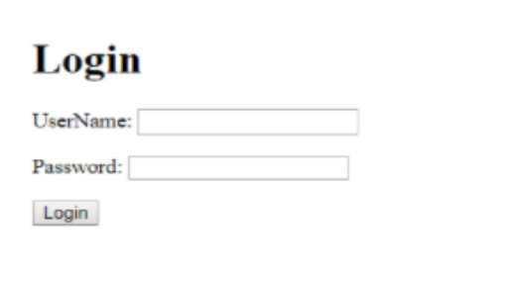

**Practical-22**

**AIM:** Write PHP Script for storing and retrieving user information from MySql table. 1. Design A HTML page which takes Name, Address, Email and Mobile No. From user (register.php) 2. Store this data in Mysql database / text file. 3. Next page display all user in html table using PHP ( display.php )

**Code:**

**connection.php:**

<?php

$host="127.0.0.1:3308";

$user="root";

$pass="";

$db="test";

$con=mysqli_connect($host,$user,$pass,$db);

if ( mysqli_connect_errno() ) {

// If there is an error with the connection, stop the script and display the error.

exit('Failed to connect to MySQL: ' . mysqli_connect_error());

}

?>

**modified.php:**

<!DOCTYPE html>

<html>

<head>

<title>Insert Page page</title>

</head>

<body>

<center>

<?php

include "connection.php";

// Taking all 5 values from the form data(input)

$Name = $_REQUEST['Name'];

$Email = $_REQUEST['Email'];

$ContactNo = $_REQUEST['ContactNo'];

$Address = $_REQUEST['Address'];

// Performing insert query execution

$sql = "INSERT INTO itwpr22 VALUES ('$Name',

'$Email','$ContactNo','$Address')";

if(mysqli_query($con, $sql)){

echo "<h3>data stored in a database successfully."

. " Please browse your localhost php my admin"

. " to view the updated data</h3>";

echo nl2br("\n$Name\n $Email\n "

. "$ContactNo\n $Address");

} else{

echo "ERROR: Hush! Sorry $sql. "

. mysqli_error($conn);

}

// Close connection

mysqli_close($con);

?>

</center>

</body>

</html>

**prac_22.php:**

<!DOCTYPE html>

<html>

<head>

<title>Reg Form</title>

<style type="text/css">

.headercont{

font-family:Tahoma, Geneva, sans-serif;

font-size: 70px;

color: #7CFF01;

border-style: double;

}

input[type=text],textarea{

background-color: transparent;

width: 95%;

color:white;

border-color: transparent;

}

input[type=text]:hover{

background-color: blue;

border-color: transparent;

}

input[type=submit]{

width: 100%;

color: white;

background-color: transparent;

}

input[type=submit]:hover{

background-color: #B2E3FB;

color: black;

}

::placeholder{

color: white;

opacity: 50%;

}

.regform{

font-family: Tahoma, sans-serif;

font-size: 23px;

color:white/*F3F315 39FF14*/;

border-style: double;

border-radius: 3px;

text-align: center;

}

.regform:hover{

border: hidden;

}

.reghead{

font-family:Tahoma, Geneva, sans-serif;

font-size: 20px;

color: #0CF;

border-style: double;

color: #FFFF00;

text-align: center;

}

.footercont{

font-family:Tahoma, Geneva, sans-serif;

font-size: 30px;

color: #0CF;

border-style: double;

}

</style>

</head>

<body style="background-image: url(bg.jpg); background-size: cover; background-repeat:

no-repeat;">

<header>

<table border="0" width="100%">

<tr>

<td width="100%" align="center"

class="headercont">Registration Form</td>

</tr>

</table>

</header>

<article>

<form method="get" id="f1" action="modified.php">

<table border="0" width="30%" align="center">

<tr>

<td class="reghead" colspan="2">Registration

Form</td>

</tr>

<tr>

<td class="regform" width="27%">Name</td>

<td class="regform" width="73%"><input type="text"

placeholder="Enter your name" name="Name"></td>

</tr>

<tr>

<td class="regform" width="27%">Email</td>

<td class="regform" width="73%"><input type="text"

placeholder="ex:myname@example.com" required name="Email"></td>

</tr>

<tr>

<td class="regform" width="27%">Contact No</td>

<td class="regform" width="73%"><input type="text"

placeholder="1234567890" pattern="[0-9]{10}" name="ContactNo"

maxlength="10"></td>

</tr>

<tr>

<td class="regform" width="27%">Address</td>

<td class="regform" width="73%"> <textarea

rows="4" cols="50" name="Address" form="regform"> Enter your address

here...</textarea></td>

</tr>

</table>

<table border="0" align="center" width="30%">

<tr>

<td class="regform" width="50%"><input type="submit"

value="Cancel" formmethod="post" formtarget="blank"></td>

<td class="regform" width="50%"><input type="submit"

value="Register" formmethod="get" formtarget="_parent" formnovalidate></td>

</tr>

<tr></tr>

</table> </form> </article>

<footer>

<table border="0" width="100%">

<tr></tr>

<tr>

<td width="100%" align="center"

class="footercont">Copyright &copy; All Rights Reserved</td>

</tr>

</table>

</footer>

</body>

</html>

**Output:**

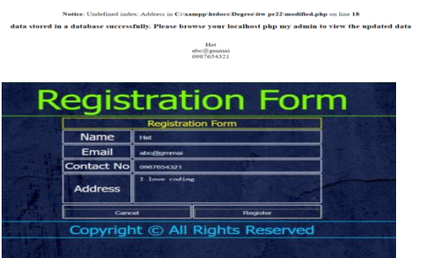

**Practical-23**

**AIM:** Create one blog website using wordpress, using different available plug-in (take free available theme) But, try to implement all the features of the blog website.

**Output:**

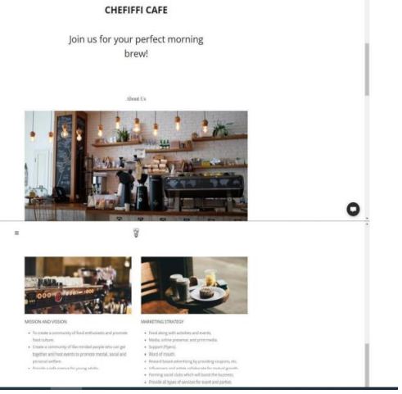

**Practical-24**

**AIM:** Implement the basic website structure using Codeigniter Framework.

**Code:**

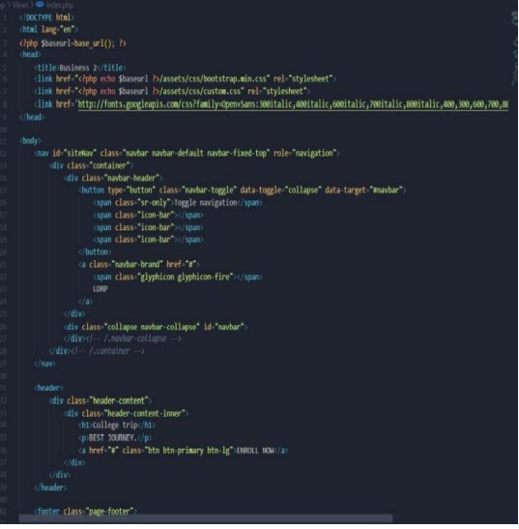



**Practical-25**

**AIM:** Using ajax fetch information from a database with AJAX.

**Code:**

**Ajax.script.js:**

$(document).on('click','#showData',function(e){

$.ajax({

type: "GET",

url: "backend-script.php",

dataType: "html",

success: function(data){

$("#table-container").html(data); }

}); });

**Backend-script.js:**

<?php

include("database.php");

$db=$conn;

// fetch query

function fetch_data(){

global $db;

$query="SELECT * from usertable ORDER BY id DESC";

$exec=mysqli_query($db, $query);

if(mysqli_num_rows($exec)>0){

$row= mysqli_fetch_all($exec, MYSQLI_ASSOC);

return $row;

}else{

return $row=[];

} }

$fetchData= fetch_data();

show_data($fetchData);

function show_data($fetchData){

echo '<table border="1">

<tr>

<th>S.N</th>

<th>Full Name</th>

<th>Email Address</th>

<th>City</th>

<th>Country</th>

<th>Edit</th>

<th>Delete</th>

</tr>';

if(count($fetchData)>0){

$sn=1;

foreach($fetchData as $data){

echo "<tr>

<td>".$sn."</td>

<td>".$data['fullName']."</td>

<td>".$data['emailAddress']."</td>

<td>".$data['city']."</td>

<td>".$data['country']."</td>

<td><a href='crud-form.php?edit=".$data['id']."'>Edit</a></td>

<td><a href='crud-form.php?delete=".$data['id']."'>Delete</a></td>

</tr>";

$sn++; }

}else{

echo "<tr>

<td colspan='7'>No Data Found</td>

</tr>";

}

echo "</table>";

}

?>

**data-list.php:**

<!DOCTYPE html>

<html>

<head>

<meta name="viewport" content="width=device-width, initial-scale=1">

</head>

<body>

<button id="showData">Show User Data</button>

<div id="table-container"></div>

<script src="https://ajax.googleapis.com/ajax/libs/jquery/3.4.1/jquery.min.js"></script>

<script type="text/javascript" src="ajax-script.js"></script>

</body>

</html>

**database.php:**

<?php

$hostname = "localhost";

$username = "root";

$password = "";

$databasename = "userdata";

$conn = mysqli_connect($hostname, $username, $password,$databasename);

// Check connection

if (!$conn) {

die("Unable to Connect database: " . mysqli_connect_error());

}

?>

**Output:**

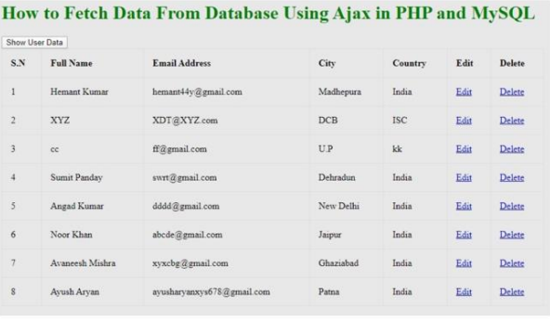

**Practical-26**

**AIM:** Install SciLab and get familiar with the general environment and console.

**Output:**

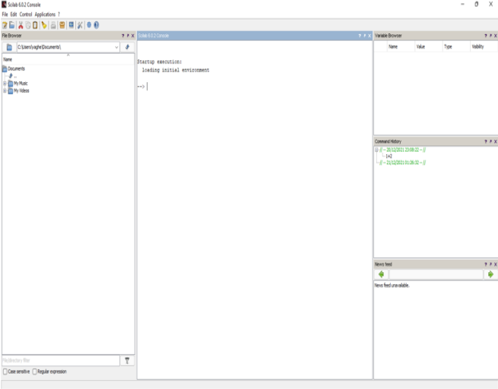

**Practical-27**

**AIM:** Get simple mathematical/numerical operations executed in SciLab.

**Code:**

Startup execution: loading initial environment

1) --> 1+2 ans= 3.

2) --> 2*3 ans =6.

3) --> 5%2

5%2

^~~^

Error: syntax error, unexpected identifier, expecting end of file

4) --> 2**5 ans =32.

5) --> 2^ 8 ans =256.

6) --> 90-1 ans = 78

**Output:**

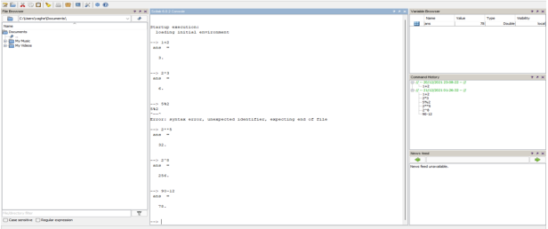

**Practical-28**

**AIM:** Plot curves/graphs using the graphics window.

**Code:**

function sinplot2(inital, final, N, v1, v2, v3)

x1=linspace(inital,final,N)

x2=linspace(inital,final,N)

x3=linspace(inital,final,N)

y=sin(2*%pi*v1*x1)

y1=sin(2*%pi*v2*x2)

y2=sin(2*%pi*v3*x3)

plot(x1,y,'O-r')

plot(x2,y1,'x-b')

plot(x3,y2,'*-g')

xlabel("x_axis(simple points"+string(N)+")")

ylabel("f(x)=sin")

title('sin plot for different frequencies')

endfunction

consol code:-

--> sinplot2(0,1,200,1,2,3)

**Output:**